Code for Extra Large Almost Sorted

*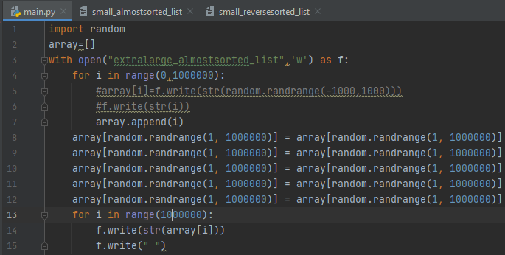*

Code for Large Almost Sorted

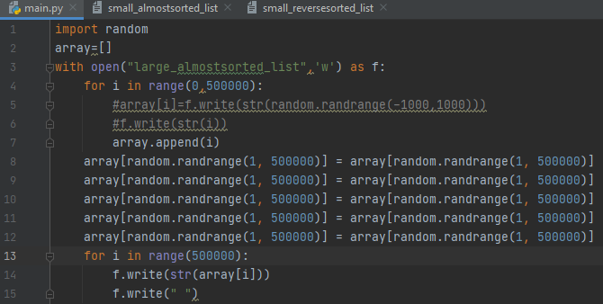

Code for Medium Almost Sorted

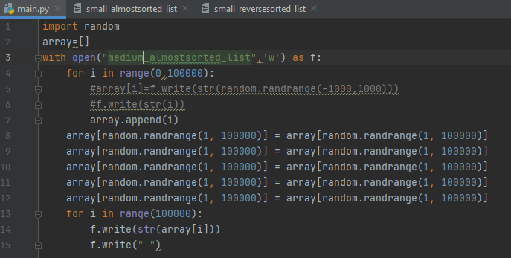

Code for Small Almost Sorted

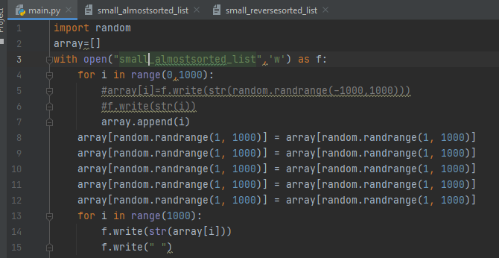

Code for Extra Large Sorted

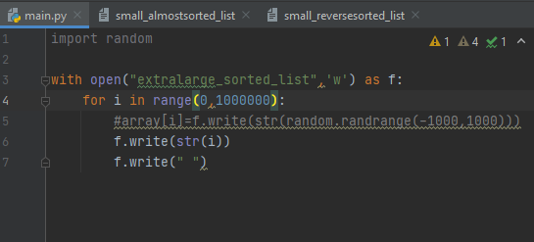

Code for Large Sorted

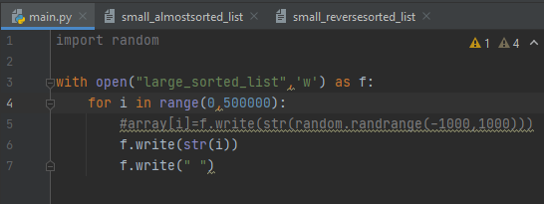

Code for Medium Sorted

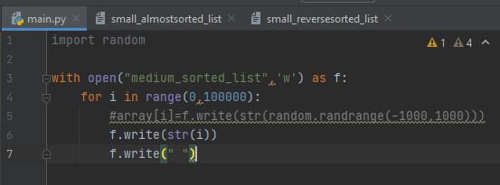

Code for Small Sorted

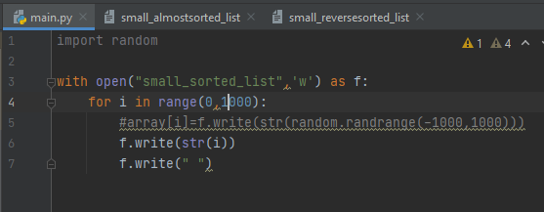

Code for Small Reverse Sorted

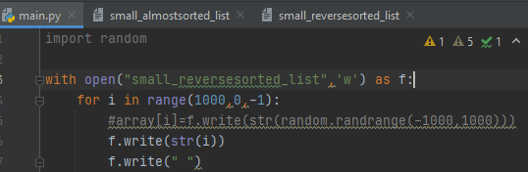

Code for Medium Reverse Sorted

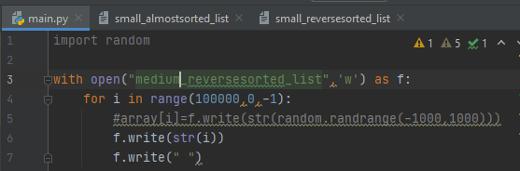

Code for Large Reverse Sorted

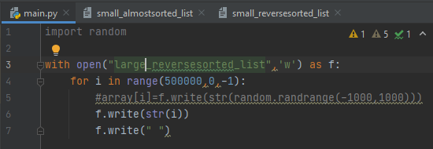

Code for Extra Large Reverse Sorted

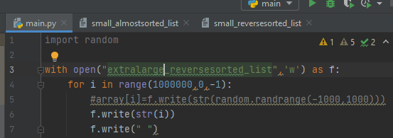

Code for Extra Large Integers

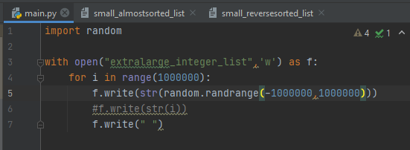

Code for Large Integers

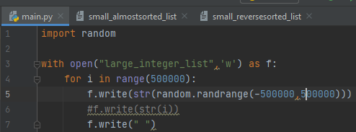

Code for Medium Integers

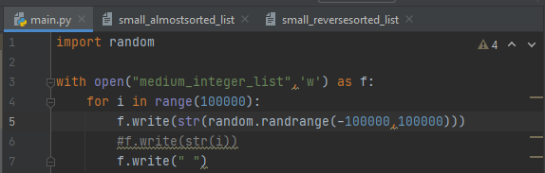

Code for Small Integers

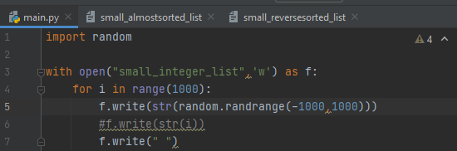

Code for Small Positive

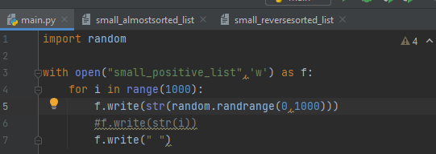

Code for Medium Positive

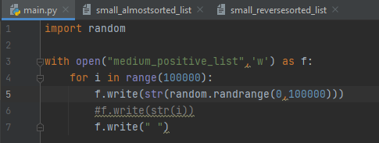

Code for Large Positive

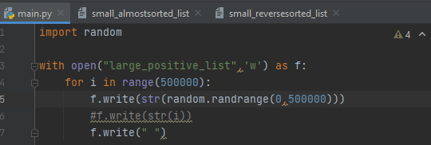

Code for Extra Large Positive

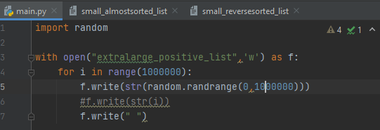

Code for Extra Large Negative

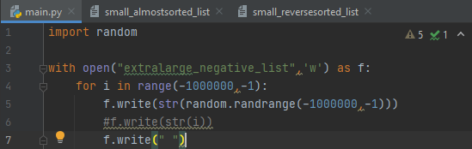

Code for Large Negative

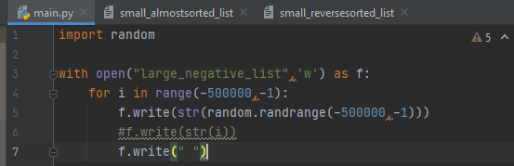

Code for Medium Negative

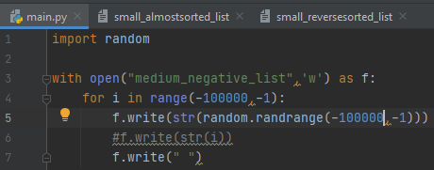

Code for Small Negative

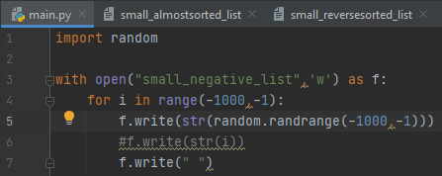

Code for Small Similar List

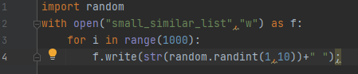

Code for Medium Similar List

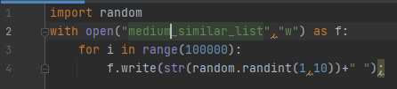

Code for Large Similar List

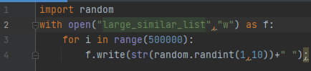

Code for Extra Large Similar List

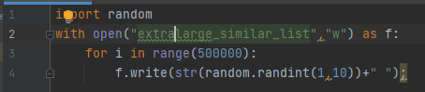

Code for Small Floating List

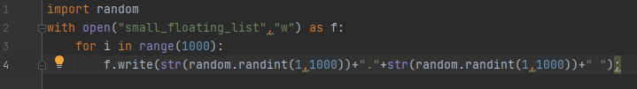

Code for Medium Floating List

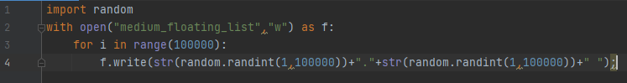

Code for Large Floating List

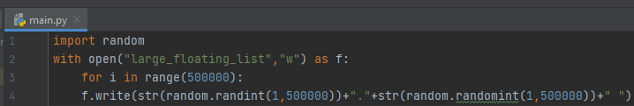

Code for Extra Large Floating List

